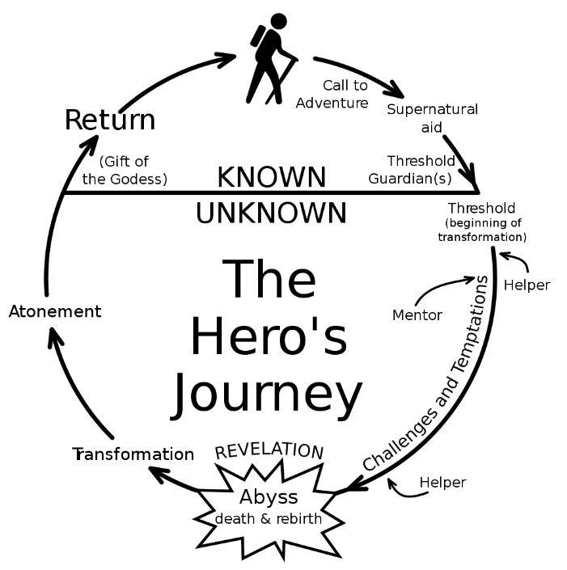

**Call to Adventure**

(Why do they go?):

**Who are their helpers?**

**Challenges & Temptations:**

**Transformation**

(How do they change?):

**Atonement**

(What mistakes do they fix?):

**Return**

(How do they get back?):



**Call to Adventure**

(Why do they go?):

**Who are their helpers?**

**Challenges & Temptations:**

**Transformation**

(How do they change?):

**Atonement**

(What mistakes do they fix?):

**Return**

(How do they get back?):